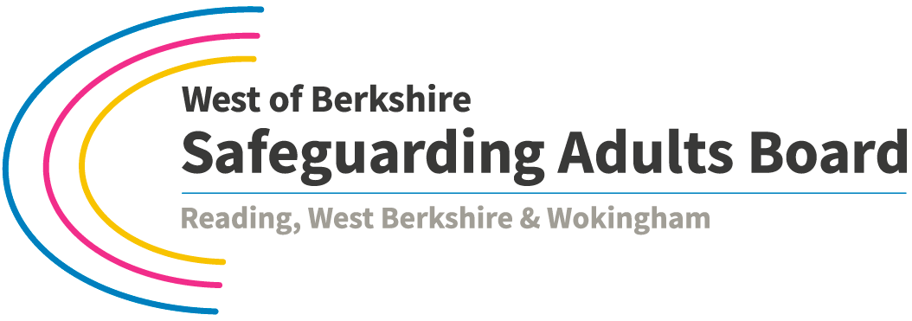

Notification of a Case for Consideration

Complete in as much detail as possible and send securely to:

Lynne Mason, Business Manager for the Board at Lynne.Mason@reading.gov.uk Tel. 07718 120601

Send a copy securely to the appropriate Safeguarding Adults Team

Please ensure that the notification has gone through the appropriate governance process within your organisations.

Report completed by name and contact details:
Date report completed:

Report Audience: | Safeguarding Adult Board (SAB) for consideration for action under the West of Berkshire Safeguarding Adults Board Guidance for Multi-Agency Safeguarding Adults Reviews of Serious Cases
Purpose of report:

Person’s Full Name
Person’s Date of Birth
Person’s Last Known Address
Person’s Date of Death (if applicable)
Person’s Contact details (if applicable)
NoK Full Name
NoK Contact details
NoK Telephone Number
NoK Email Address
Are there any safeguarding concerns for children or other adults from this case that need to be actioned and / or shared with Local Authority adult or children safeguarding teams? If so, confirm what action has been taken
Has a S42 enquiry been completed? If yes please provide the outcome of this enquiry and if no please explain why not.
Section 1 – Summary of case
Section 2 – Information received and documents reviewed
Section 3 – Evaluation of information received and documents reviewed
Section 4 – Conclusions
Signed by:
Dated:

